**# Steps to Perform Ansible**

* Create EC2 Instance for the Ansible and the Nodes.

* Connect on EC2 Ansible.

Install Ansible

cmd: sudo yum install ansible -y

* Check Ansible version to verify it is installed correctly.

cmd: ansible --version

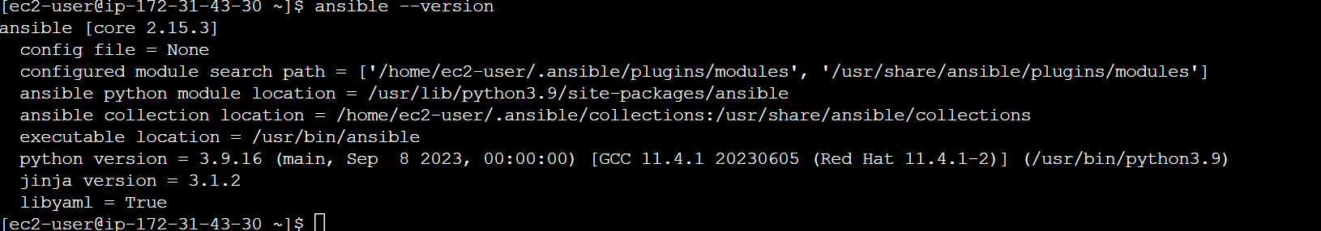

* Configure Ansible.

* Establish SSH Connection.

cmd: ssh-keygen

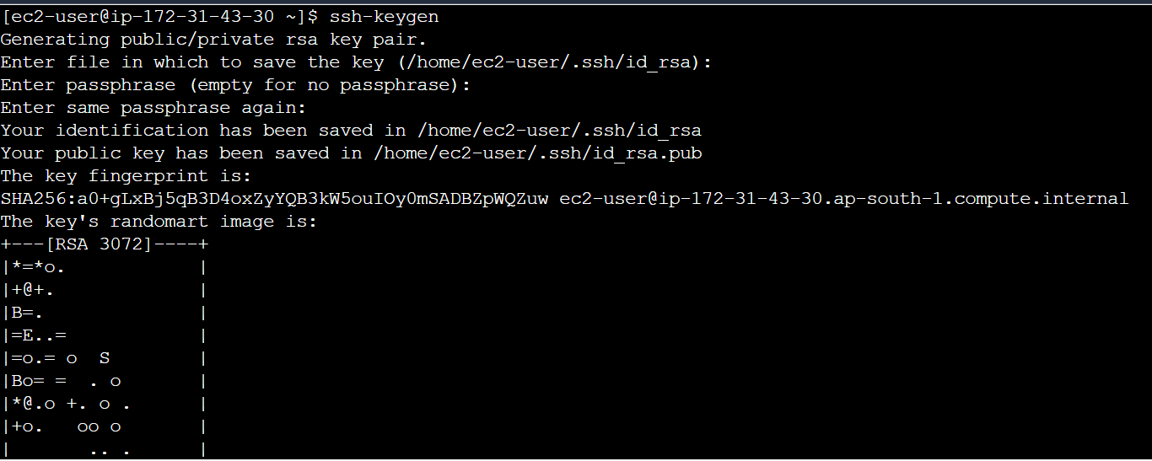

* Connect To Node EC2.

* Check the Authorized keys in the Node and add the public key from the ansible into the

node authorized key to establish the connection.

cmd: cd .ssh (cd: To Go to SSH directory)

cmd: ls (ls: Lists Instance Directory and file)

cmd: vi authorized_keys (vi: Used to create and edit files)

* Ansible Public key.

cmd: cd .ssh (cd: To Go to SSH directory)

cmd: ls (ls: Lists Instance Directory and file)

cmd: cat id_rsa.pub (vi: Concatenate or Display the Content of the File)

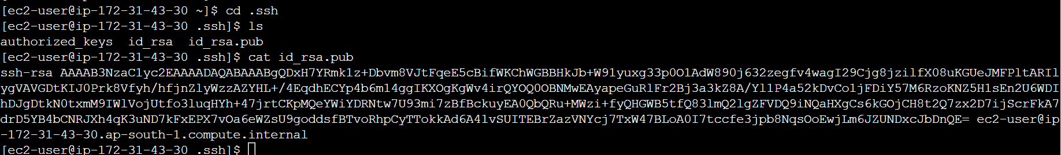

* Copy the Public key from Ansible and Paste it in Node.

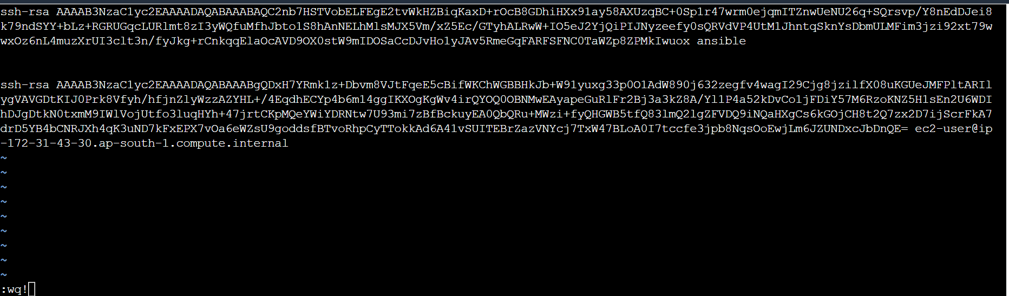

* Repeat the same process for the other nodes.

* Create the inventory file and add the Nodes Private IP address into inventory file.

cmd: sudo vi /etc/ansible/hosts

/etc/ansible/hosts (Default Path of Inventory file)

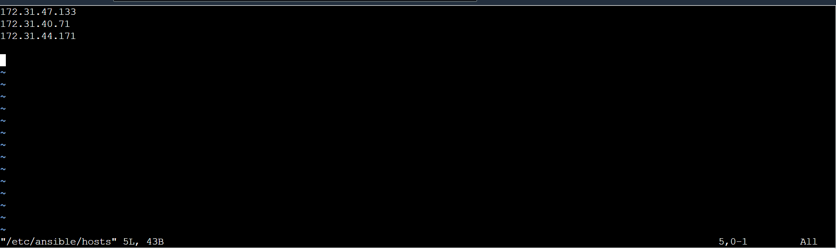

* Edit the inventory file and add the Nodes Private IP address.

* Ping all the Nodes IP’s.

cmd: ansible all -m ping

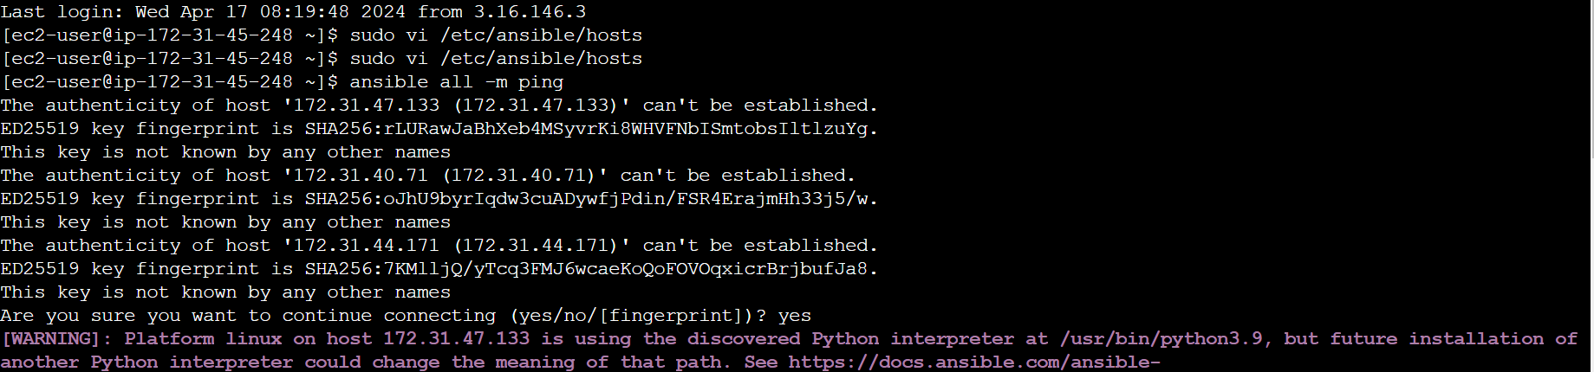

When it try to establish the connection with the ssh it asks for the verification to overcome this put false the verification.

* Put all the Host key verifications put false as by default it is set to true if you are establishing the

connection with the multiple IP.

cmd: sudo vi /etc/ansible/ansible.cfg #Create the Config file

[defaults]

Host_key_checking = False

* To verify if the following ansible.cfg file is created or not.

cmd: cd /etc/ansible

cmd:ls

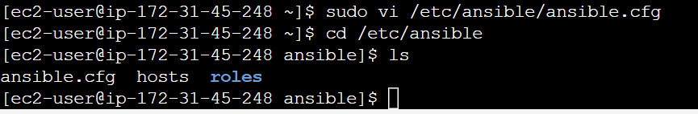

* Control the Nodes through grouping concept so we can perform the any action in a particular node.

cmd: sudo vi /etc/ansible/hosts

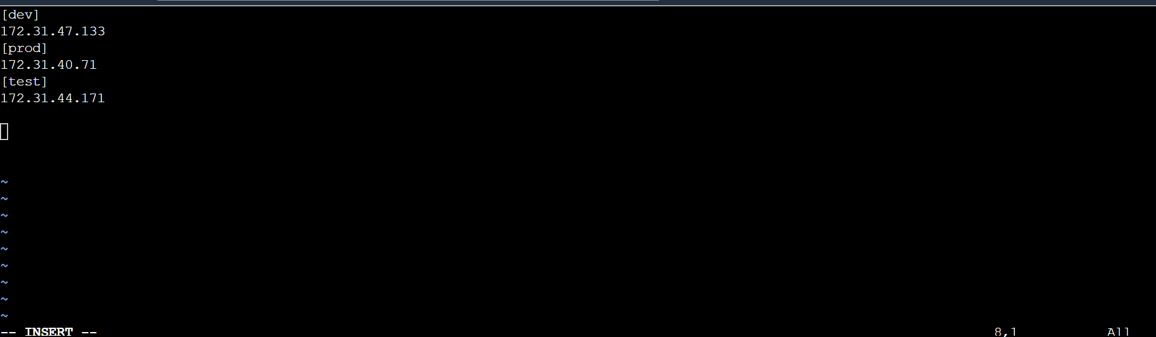

* Playbooks – are used to create the multiple tasks in one time.

- To perform the tasks, we have to create the yml file.

cmd: ansible-playbook example.yml

* Create the yml file and Install services by using the playbook yml.

cmd: vi example.yml

- name: techno playbook (Give any name)

hosts: all (All Nodes)

become: yes (Root User Permissions)

tasks: (What need to perform)

- name: install docker software

yum: (Module)

name: docker (Name of the service need to install)

state: latest ()

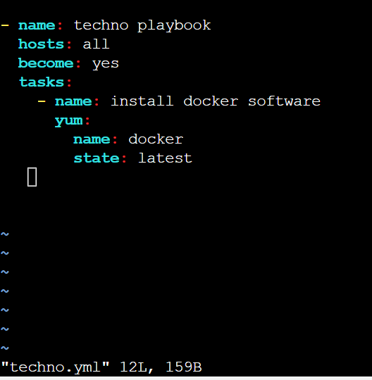

cmd: ansible-playbook example.yml

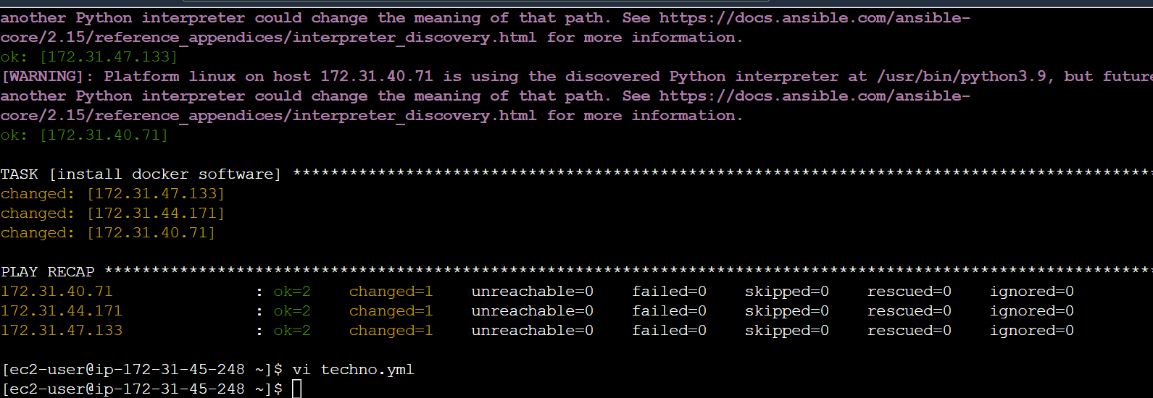

* Connect with the Nodes and check the status of the services.

Cmd: systemctl status httpd

* Test with the Group playbook now.

cmd: sudo vi /etc/ansible/hosts

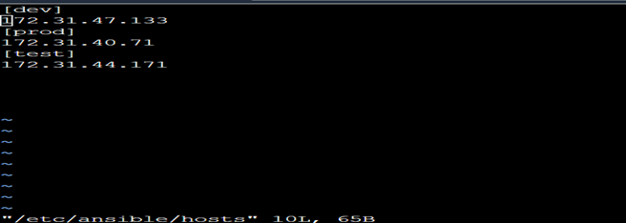

hosts: [prod]

become: yes

tasks:

- name: install docker software

yum:

name: docker

state: latest

It will install the docker in the prod Node only.

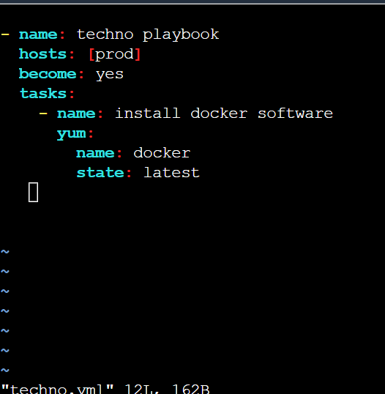

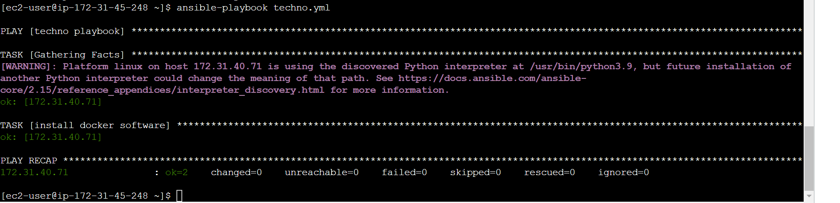

* Connect